Week 4 Report:
Exploring Default Snort Rules, Rule Structure, and Reporting
1. Objective
The objective of Week 4 is to explore Snort’s default rule structure, understand rule components, analyze configuration files, and prepare a structured report with relevant screenshots.

2. Exploring Snort Directory Structure
Commands used:
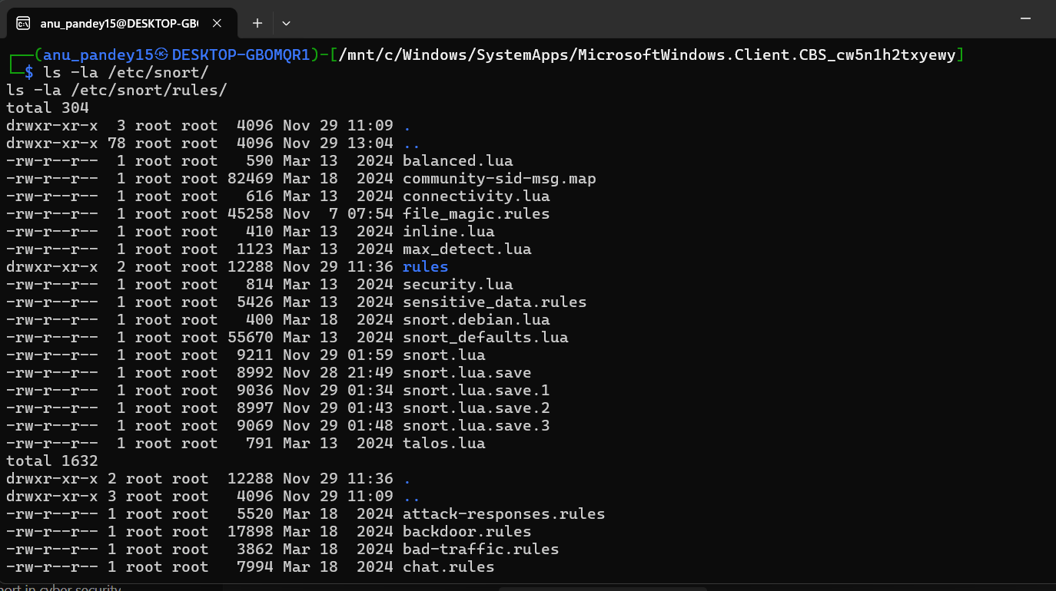

3. Reviewing snort.conf File
The main configuration file was opened:
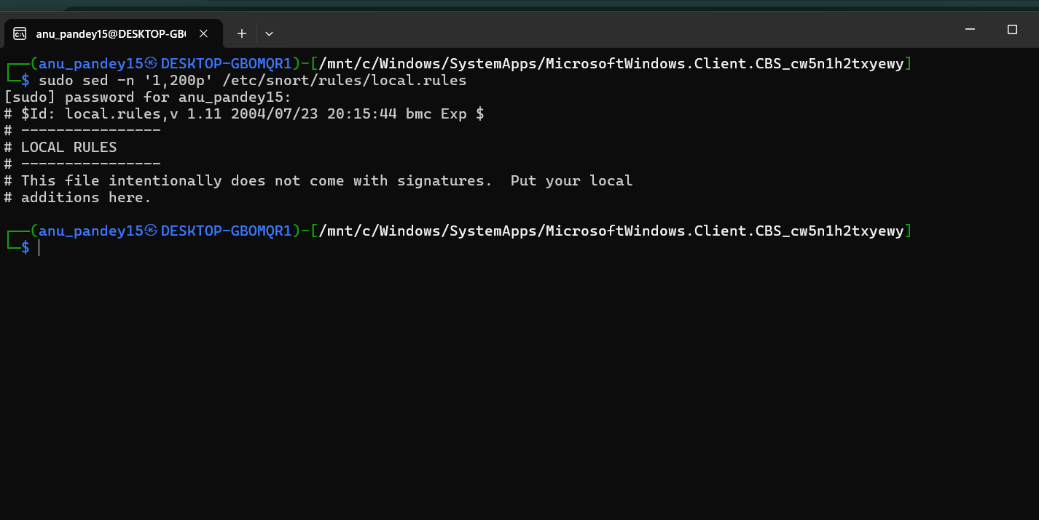

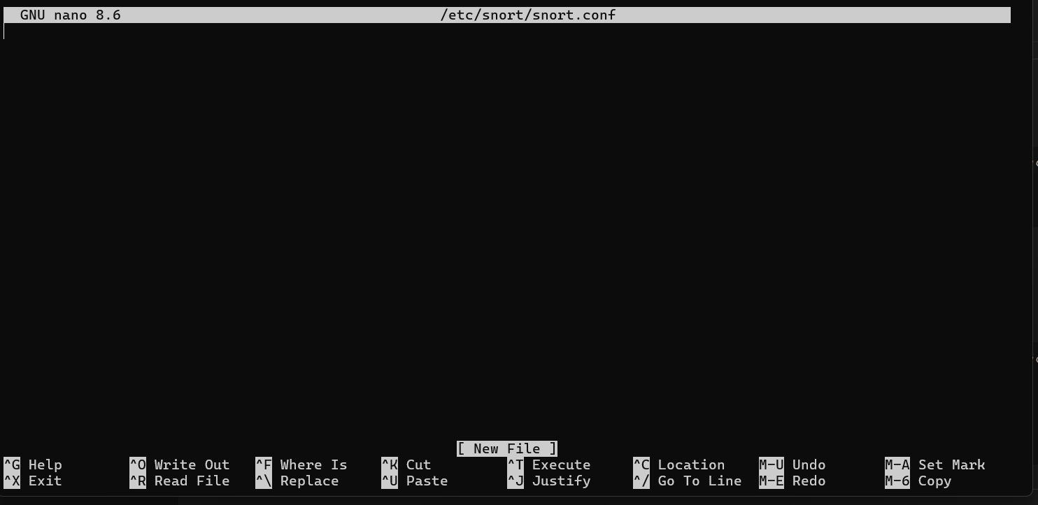

4. Understanding Snort Rule Structure
A Snort rule has two main parts:
4.1 Rule Header

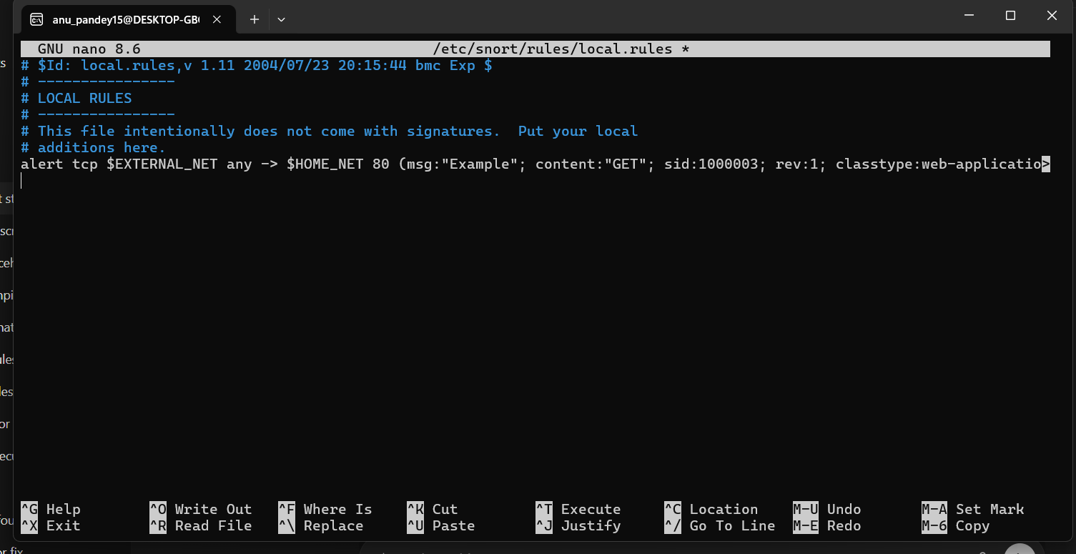

5. Validating Snort Configuration
Configuration was tested using:
